MSIM 508

Introduction to Game Development

Programming Assignment #3

***Tank Game Part II***

March 8, 2017

Mark Brosche

Major: MSVE - Master of Engineering

Online Distance Graduate - Outside Virginia (Saratoga Springs, NY)

[mbros006@odu.edu](mailto:mbros006@odu.edu)

407-325-2818

**Assigned March 15, Due 12:00 PM April 12, 2017**

**INTRODUCTION**

The assignment was hugely daunting at first, however, it can be played from start to finish with good player engagement. The assignment was to create a helicopter game extending from P_2 where tanks would be wandering NPCs, and the player would pilot a helicopter (realistically) to rescue a downed soldier and fight off enemies in bunkers and enemy tanks before returning to base.

All code was written by me, but models and audio were sourced from the Asset Store, and royalty-free sources on the internet.

**GAME DESIGN AND IMPLEMENTATION**

**Files:**

P_3_Brosche_Mark.exe

**CONTROLS**

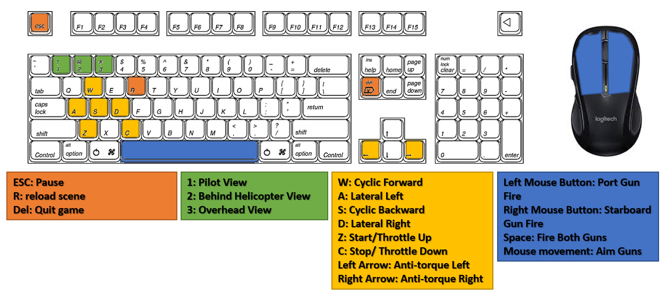

**CODE ARCHITECTURE**

**Class Diagram:**

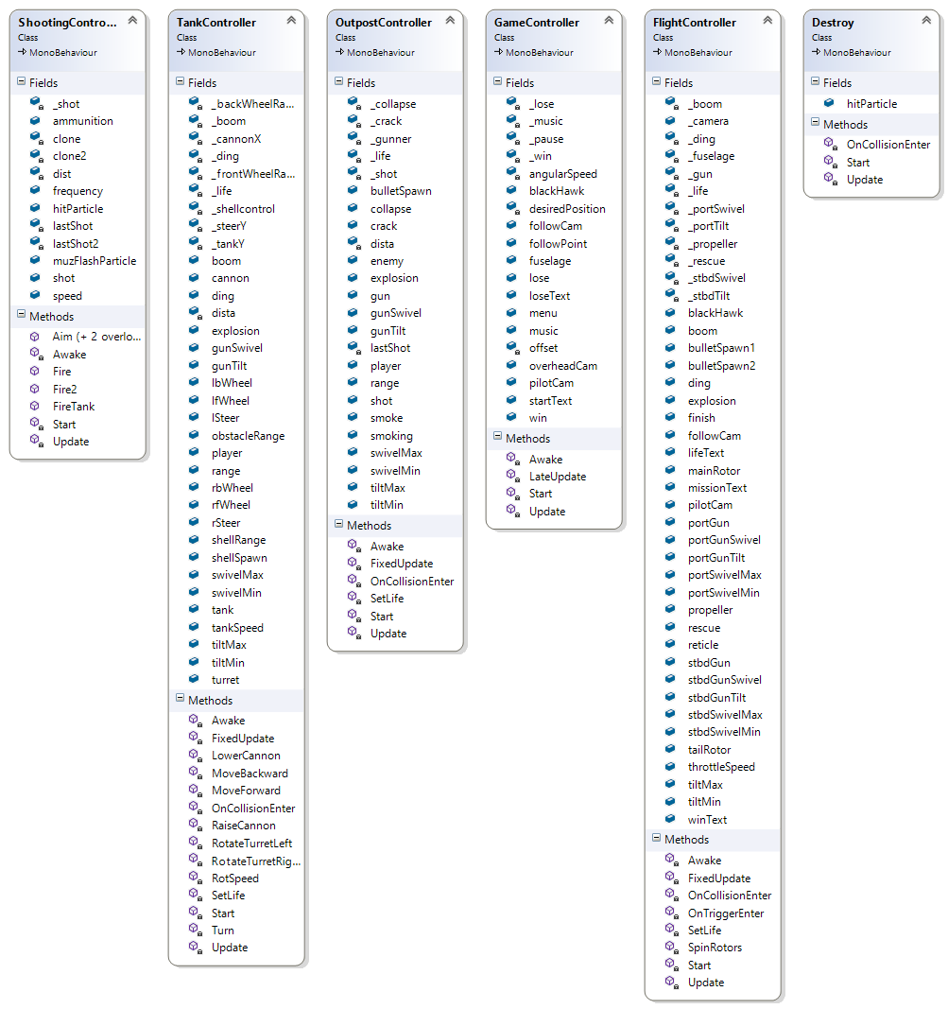

**ASSETS**

Scripts:

TankController.cs

GameController.cs

OutpostController.cs

ShootingController.cs

FlightController.cs

Models:

Tank (from P_2)

RoundBunker (from SketchUp)

Bullet (from SketchUp)

BlackHawkFinal (Provided for assignment, modified with Maya)

Soldier (from Soldiers Pack in Unity Asset Store)

Rock_01_LOD4 (from 3D Scanned Rocks 1 2.0 in Unity Asset Store)

Materials:

Shell

Metal

Brown

Prefabs:

BigExplosionEffect (Particle)

BlackHawkFinal

Boundary

Bullet

BulletImpactMetalEffect (Particle)

Canvas

Enemy_Tank

Follow Camera

Game Controller

MuzzleFlashEffect (Particle)

Overhead Camera

RoundBunker

Shell

SmokeEffect (Particle)

Targeting

Audio:

Boss Kill (reuse from P_2)

Bullet Hit (reuse from P_2)

Bunker Hit (reuse from P_2)

Clear (from Solder Radio Voices Packs 1.0 in Unity Asset Store)

Helicopter (edited and sourced from Soundbible.com)

Instructions (self-recorded using Audacity)

Sad Trombone (from freesound.org)

Shell Fire (reuse from P_2)

Smoking Gun (from purple-planet.com)

Sniper Shot (reuse from P_2)

Tank Death (reuse from P_2)

Tank Engine (reuse from P_2)

Victory_song (reuse from P_2)

# RESULTS

# My results are below formatted as responses to the tasks set for the assignment (all pictures are below in “Important Screen Captures”):

1. Helicopter modeling
   1. Helicopter model was fixed using Maya 2017 with separate and correct pivots for the fuselage, main rotor, tail rotor, and miniguns.
   2. The helicopter miniguns were fixed to allow the gun to tilt about the proper axis and to drive the swivel arm it is mounted on, allowing realistic pivots independently of the helicopter fuselage.
2. Helicopter movement and operations
   1. In my review of the 2-axis control of the propeller plan in the standard example script, I saw the level of complexity allowed with creating realistic-seeming movements via rigidbody physics simulation. I did not however go into that level of detail with my FlightController script. Using the assigned keys for control, I added relative linear acceleration forces for cyclic motions, relative linear impulse forces for collective motions, and relative torque impulse forces for the anti-torque pedals. Rotors are spun with the transform.Rotate and based on throttle speed.
   2. Once the helicopter throttle speed is high enough (hold z), the helicopter will achieve lift and start to hover, and it can then be flown around the map. Engine pitch is also controlled by throttle speed in a semi-realistic way.
   3. Bullets fired from the miniguns travel in the direction of aim. Aiming is based on mouse screen position and a camera raycast. The guns will orient themselves within realistic limits though, so aiming will not always show where the guns are pointing.
3. Tank artificial intelligence
   1. I tried to implement a wandering AI for the tanks, but ran out of time. They do aim and fire upon the player within the required parameters, but movement is buggy.
   2. My tank movement code is mostly the same as from P_2.
   3. The cannon and turret move within the required parameters, however I wanted to implement rigidbody forces to move the tank and ran out of time to complete that feature.
   4. Tank firing range is default to 100, but can be adjusted in the inspector.
   5. I attempted to condense my movement code into distinct functions for the AI, however I did not finish this part in time.
   6. I created a navmesh that successfully limited where tanks could drive.
4. Generate three cameras:
   1. I adapted my own GameController script to switch between the three cameras as required. For the follow and overhead cameras, the position offset is set and updated only if the camera and players are active (i.e. not dead).
5. I used particle systems for explosions, smoke, bullet hits, and muzzle flashes, which are used by the player, enemies, and all ammunition.

**Game play**

1. The overall goal is to rescue a wounded soldier who is hiding behind a rock and invisible to the enemies. The battlefield contains one Black Hawk helicopter, the wounded soldier, two enemy tanks, and enemy soldiers inside bunkers.
   1. My game matches this requirement
   2. The GameController displays start, pause, and lose GUI text as well as detection of Pause, Quit, Camera switch, and Reload commands. Music is also played from this script once the instructions are finished.
   3. The Black Hawk prefab initializes with audio instructions to the player for what to do.
   4. Shooting is a universal script that covers bullets and shells, player and enemies.
2. Design and implement the game. Your game should contain the major components and interactions to achieve the goal stated in Task 6.
   1. Terrain and other ground objects – I have geometry, water, trees, boulder, and multiple textures.
   2. Firing between the Black Hawk and its enemies – player health = 20, enemy health = 3, everyone explodes when dying. Tanks shoot shells, while everyone else shoots bullets.
   3. User interface – pause menu with key hint, life, objective, start, lose, and win messages.

# IMPORTANT SCREEN CAPTURES

Start:

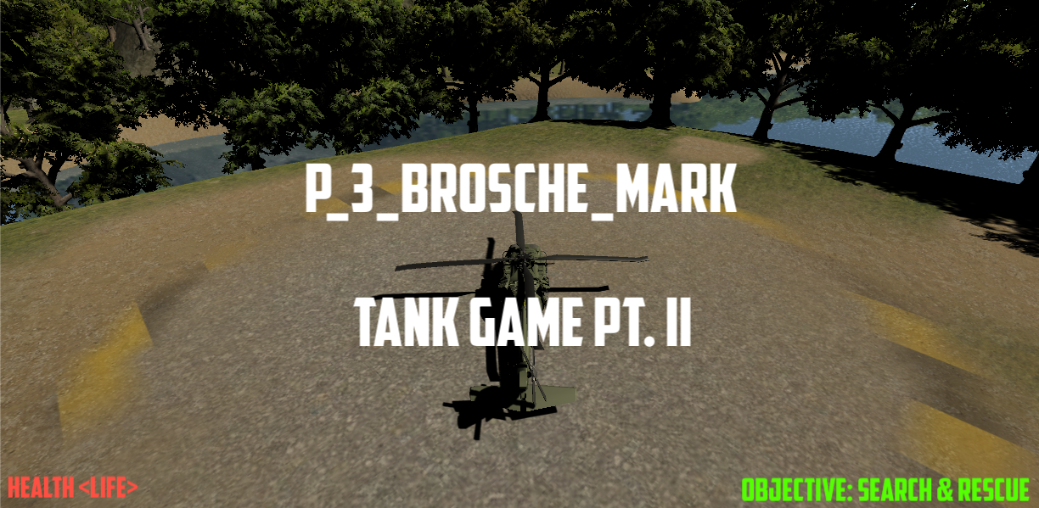

Finish:

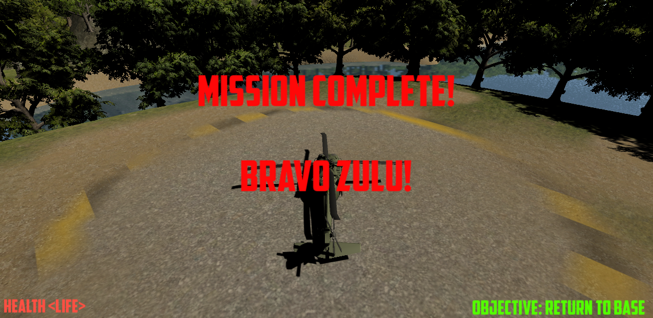

3rd person (Follow) view and Miniguns firing:

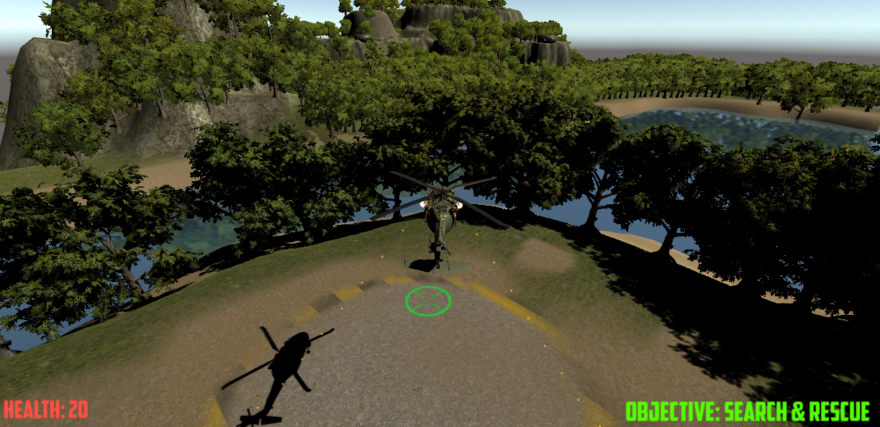

Pilot View:

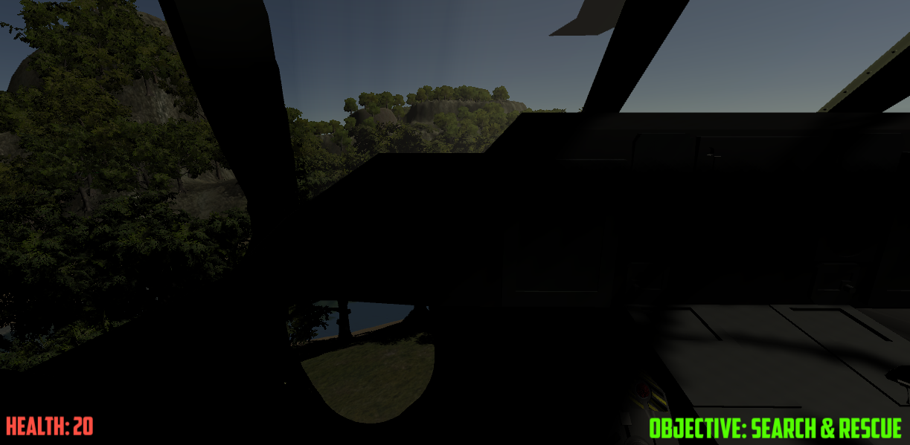

Overhead View:

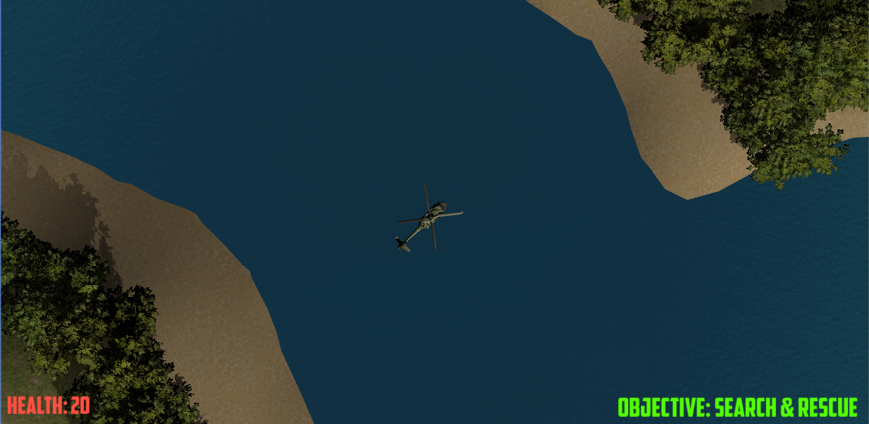

Enemy bunker firing on player:

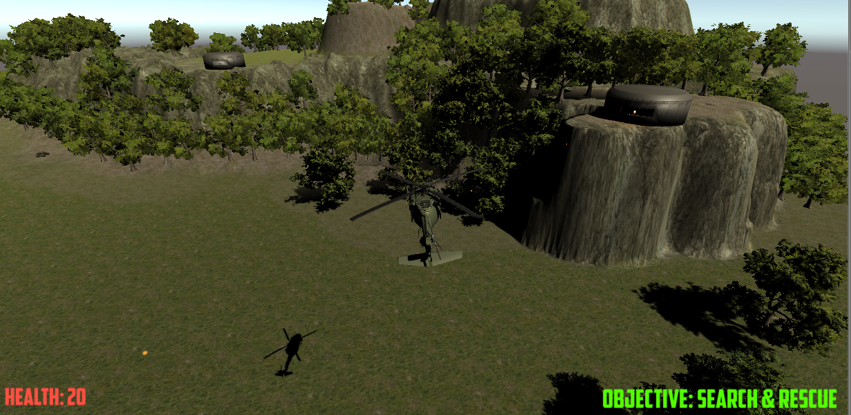

Enemy tank firing on player:

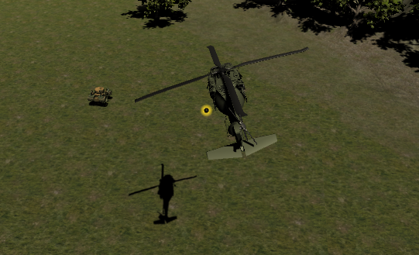

Injured soldier hiding behind boulder:

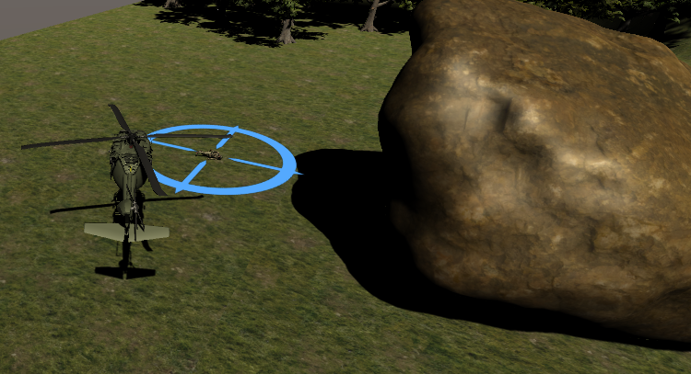

Player death:

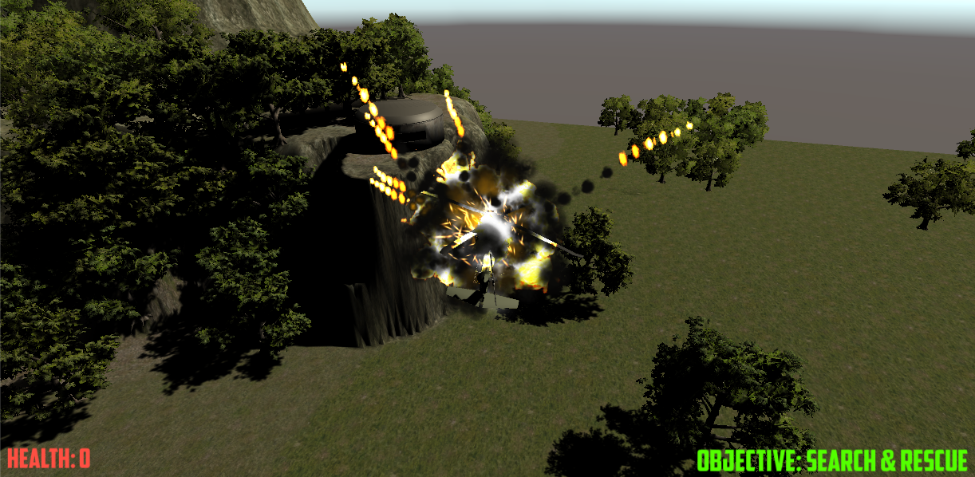 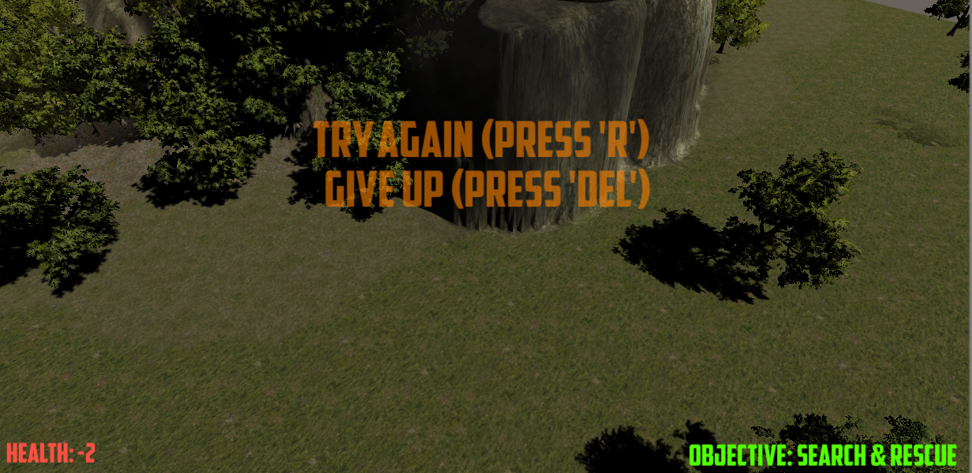

# CONCLUSION AND DISCUSSION

Overall I think I matured my coding somewhat with this project. I was able to condense the shooting and aiming control in the game to a single script that serves players and enemies alike and independent of the ammunition used. I was not able to finish the Wandering AI for the tank in time, but I did explore the use of sphere-casting and navmeshes during my development. This project easily exceeded 40 hours of work. Unity is certainly a powerful tool, but the larger the scope of any project will make the testing and bug-hunting balloon out of control.